3.

Sequence diagram, Common Goal Card Completion:

Focus on the method manageTurn, called on a Game instance by TurnController.

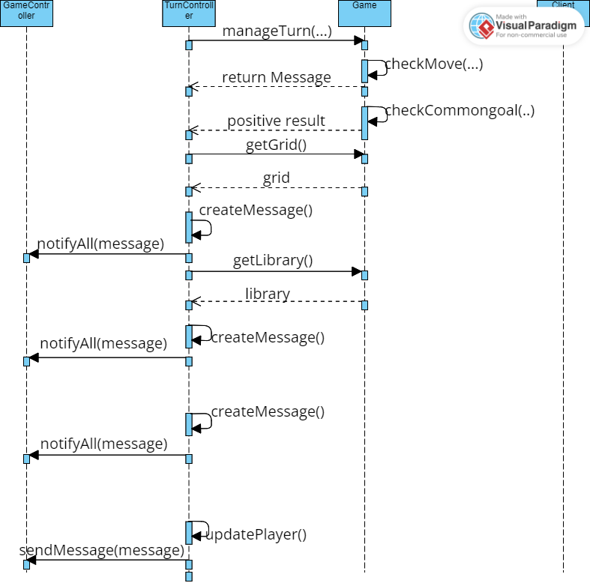

First of all, this method makes a control on the turn player’s move, calling the method checkMove.

In case of a positive outcome, the move will be done, so there will be modifies on both the library and the grid.

Before concluding, the method checkCommonGoal will be invoked, because the library has been modified.

Now TurnController requests the game grid and library, to let every player see them, after the double notifyAll invocation on GameController.

After this, supposing that the common goal has been satisfied, TurnController will create another message to send it with notifyAll (again on GameController) to all the players, not only the common goal card owner.